**RECIPES**

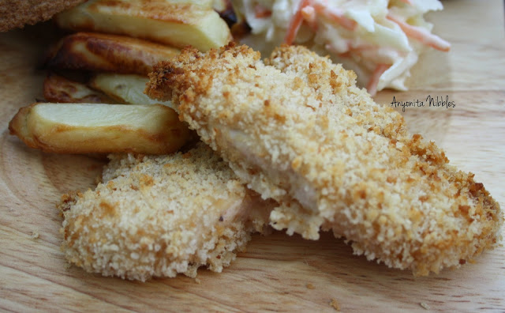

**Baked Chicken Fingers (serves 4)**

**Ingredients**

* 1/3 cup all-purpose flour
* 1/2 teaspoon salt, divided
* 1/2 teaspoon pepper
* 2 large eggs
* 1 1/2 cup Panko breadcrumbs
* 1 teaspoon sweet paprika
* 1/8 teaspoon garlic powder
* 5 teaspoons canola oil
* 4 chicken breasts, cut into 1 inch strips

**Instructions**

1. Preheat oven to 400 degrees F. Place parchment paper on baking sheet.
2. Mix all-purpose flour with 1/8 teaspoon salt and pepper in a shallow dish.
3. Beat eggs in a second shallow dish. Set next to the flour.
4. Stir breadcrumbs, paprika, garlic powder and the remaining 1/8 teaspoon salt in a third shallow dish. Drizzle oil over the breadcrumb mixture and then mix thoroughly with a fork until all of the oil and spice coats the breadcrumbs.  Set to the side of the egg mixture.
5. Use one hand for dry ingredients and one for wet ingredients while dredging the chicken. Dip a chicken strip in the flour mixture, turning to coat completely. Dip into the eggs, coating completely.  Press into the breadcrumb mixture, turning to coat completely.  Set on the prepared baking sheet. Continue with the remaining chicken one at a time. Discard any left-over dredging mixtures.
6. Transfer the baking sheet of breaded chicken strips into the oven and bake until the chicken is cooked through, 22 to 25 minutes

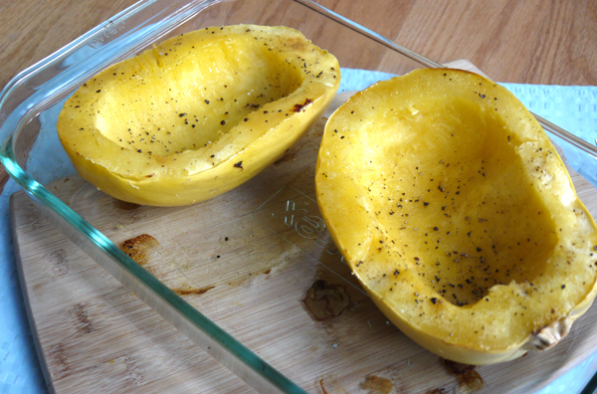

**BAKED SPAGHETTI SQUASH (serves 4-6)**

**To Prepare 1 Large Spaghetti Squash:**

1. Preheat the oven to 400 degrees. Cut the squash in half, remove the seeds (with a spoon or ice cream scooper), and bake on a baking sheet for about 45-55 minutes until tender (you should be able to pierce through the flesh easily). Note that baking times may vary based on the size and thickness of your squash. If you over-bake, the strands of spaghetti squash will become mushy (potato-like) when you scrape them out, so be sure not to over-bake them.
2. Using a spoon, start to scoop out and separate the flesh of the spaghetti squash until all that remains is the outer shell. You'll notice that the flesh of the squash comes out in strands similar to spaghetti (hence the name "spaghetti squash").

**SPAGHETTI SQUASH WITH GARLIC BUTTER**

**Ingredients:**

1 medium/large spaghetti squash  
2 tablespoons butter  
2 cloves garlic, finely minced  
1/4 cup finely minced parsley   
1/2 teaspoon salt (or to taste)  
1/4 cup shredded parmesan cheese

1. Cook the spaghetti squash as per the instructions above.
2. Heat a large sauté pan with the butter and the garlic over medium-low heat. When garlic becomes fragrant, add parsley, salt and spaghetti squash strands. Toss well, sprinkle in the parmesan cheese and taste to see if you need additional salt. The spaghetti squash should have a slight crunch (i.e. not mushy) - but if you like it softer, cover the pan and cook 2 more minutes.

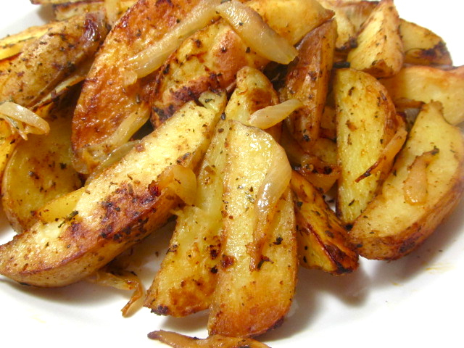

**BAKED FRENCH FRIES (SERVES 4)**

**INGREDIENTS**

6 Potatoes

2 Tbsp Oil

1 Tsp seasoning such as garlic plus

**INSTRUCTIONS**

1. Preheat oven to 400 F
2. Wash potatoes and cut into wedges (eight per potato)
3. Use parchment paper or spread a little oil on a baking sheet
4. Toss potato wedges in a bowl with oil
5. Sprinkle with seasoning
6. Bake for approximately 45 minutes or until golden brown and crispy. Turning wedges over after 20 minutes.

